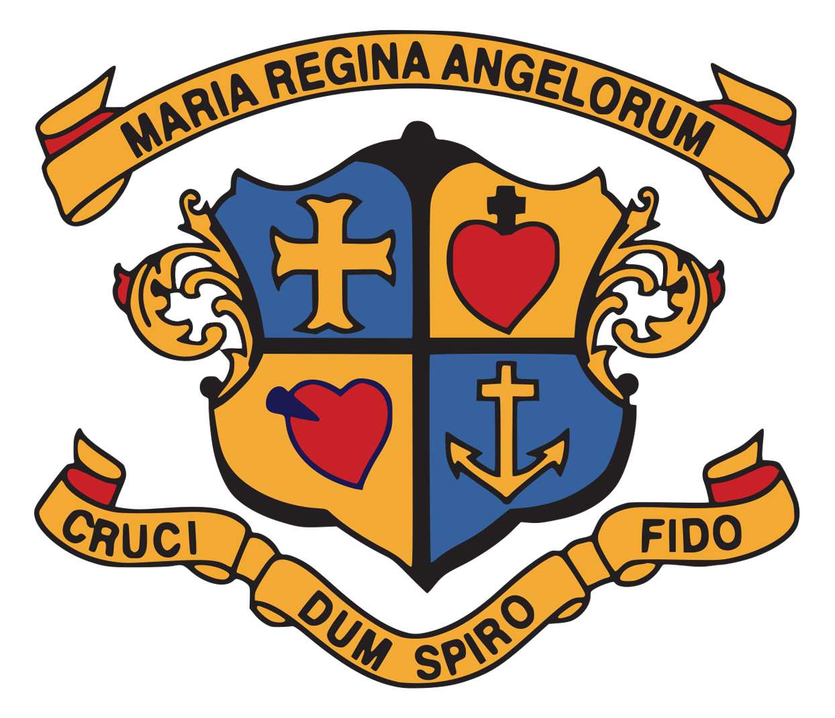
Office Use: Received by:______
Date:___________ Time:______
St. Anne’s Loreto Primary School,
FAIRGREEN, NAVAN, CO MEATH

TEL: 046 9023039 EMAIL: office@stannesnavan.ie www.stannesnavan.ie

APPLICATION FOR ADMISSION
JUNIOR INFANTS – ACADEMIC YEAR 2025/26

Admission Period 1st October – 22nd October 2024

St Anne’s Loreto Primary School is under the patronage of the Catholic Bishop of the Diocese of Meath.

Child’s family name ___________________________________________________
(as on birth certificate)

Child’s first names ___________________________________________________
(as on birth certificate)

Male Female Date of Birth ___________________PPSN _________________

Current permanent address of child (strictly where child normally resides)
EirCode must be included to adhere to Department of Education guidelines.

________________________________________________________________________

________________________________________________________________________

Parent 1 ______________________________ Nationality ____________________

Mobile No. _________________ Email Address ______________________________

Parent 2 ______________________________ Nationality ____________________

Mobile No. _________________ Email Address ______________________________

Guardian’s name (if applicable) _______________________________________________

Home telephone no. _____________________ Mobile No. _________________________

Does the child have a brother or sister currently attending this school?
Yes No

Name(s) of brother(s)/sister(s) _________________________________________

_________________________________________

Has the child been enrolled in Junior Infants in another school?
Yes No

If yes, please provide name of school: _______________________________________

Please provide your child’s BIRTH CERTIFICATE (original only) with this form.

All applications will be assessed according to the school’s Admission Policy and applicants will be notified in due course.

Declaration of Parent (s) / Guardian(s) (as appropriate)

We / I declare that the information provided above is true and accurate.

Signed:

Parent 1 ______________________________________________________
Parent 2 ______________________________________________________
Guardian ______________________________________________________
Date ______________________________________________________

Completed application form to be returned to the school
on or before 12 Noon on Tuesday 22nd October 2024 to

The Principal, St. Anne’s Loreto Primary School, Fairgreen, Navan, Co Meath C15 E208
Love of
Learning
Meaningful
Work
Enjoyment
Inclusion
Respect
St. Anne’s
Mission statement

Mission Statement
Reaching
Potential
St. Anne's

GDPR NOTICE
The personal data provided on this form will be used solely for the process of assessing the Application for Admission to the above school. In the case of successful applicants, the form, together with a copy of the birth certificate, will be retained on the child’s file in the school.

In accordance with the Education (Admission to Schools) Act 2018 §66 (6), the above School may, in order to facilitate the efficient admission of pupils, share all or some of the data on the Application for Admission form with other Schools in the Navan Area and with the Navan Enrolment Monitoring Body.

Navan Schools under the Patronage of the Catholic Bishop[ of Meath
St. Anne’s Loreto Primary School; Scoil Mhuire; St. Oliver Plunketts National School; Scoil Bhríde, Cannistown; Scoil Naomh Eoin; St. Joseph’s Mercy Primary School; Gaelscoil Éanna; St. Paul’s Primary School.

Navan Schools under the patronage of Educate Together: Navan Educate Together National School

